Rising Stars Gymnastics Academy

520 Hayward Avenue North—Oakdale, MN 55128

651-730-4376 [www.risingstarsgym.com](http://www.risingstarsgym.com)

**Gymnastics Birthday Parties**

September 2024 – May 2025

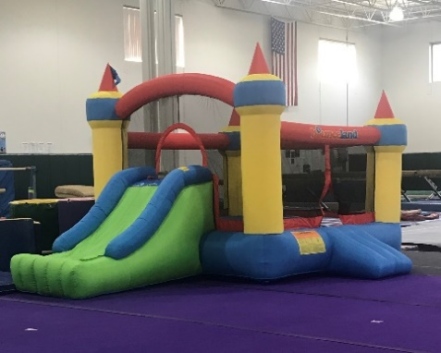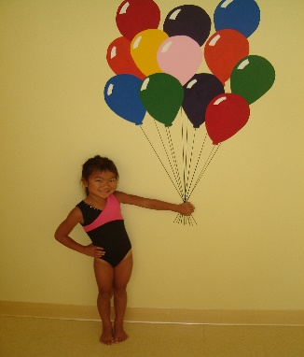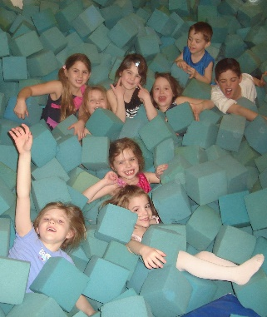

Celebrate your child’s birthday in a special way! Rising Stars offers an entertaining and fun-filled party tailored to your needs with no mess to clean up afterwards! Parties include gymnastics activities and use of our party room for refreshments and gift opening!

**What We Provide:** Invitations, a gift for the birthday child, supervised gymnastics such as obstacle course, trampoline and tumble track, pit fun, parachute games and fun in our ultimate bouncer! To top it off – we set up and clean up!

**What You Provide:** We recommend juice boxes and cupcakes, plates, napkins, balloons and party decorations. You, along with our staff, will supervise refreshments and gift opening in our party room.

**Party Times Available:**   
Saturdays—12:30 pm **Parties cannot run longer than the given time, or you will be charged $15 per every 5 minutes after

**Cost For Parties:**  ***Bronze Party*:** $**210.00** – 1 hour of gymnastics only! –maximum of ten children including birthday child.

***Silver Party*:** $**250.00** – 1 hour of gymnastics and 30 minutes in the party room – maximum of ten kids including party child.

**\*\*\*Note: Parties that exceed the maximum number of guests will be charged a $25 fee per extra guest. For safety reasons, no more than 2 extra guests will be allowed to participate in ANY party. No exceptions.**

**\*\*\*For parties with children ages 3-4, the maximum number of children is eight (including birthday child) for safety reasons**

**Things To Know:**

* There is a $50.00 deposit required at the time of scheduling your party. Balance is due by/on the day of the party.
* Host family can arrive up to 30 minutes prior to your scheduled party time. Guests should not arrive more than 10 minutes before scheduled party time.
* In the party room there will be banquet tables and chairs for the guests. There is also a table for presents and treats. Some parents add decorations such as balloons, etc., but it is certainly not necessary; most do not.
* No adults are allowed on any of the gym equipment.
* We’re here to help you during the party room time if you like. Just ask the coach for any help you’d like at that moment. We don’t want to interfere with your time with the kids during the eating and present opening, so we usually go into the gym to straighten it up.
* **Parents of the birthday child are welcome to video the party and take pictures from inside the gym (MUST SIGN A WAIVER. All other parents or guardians must view the party from our lobby.**